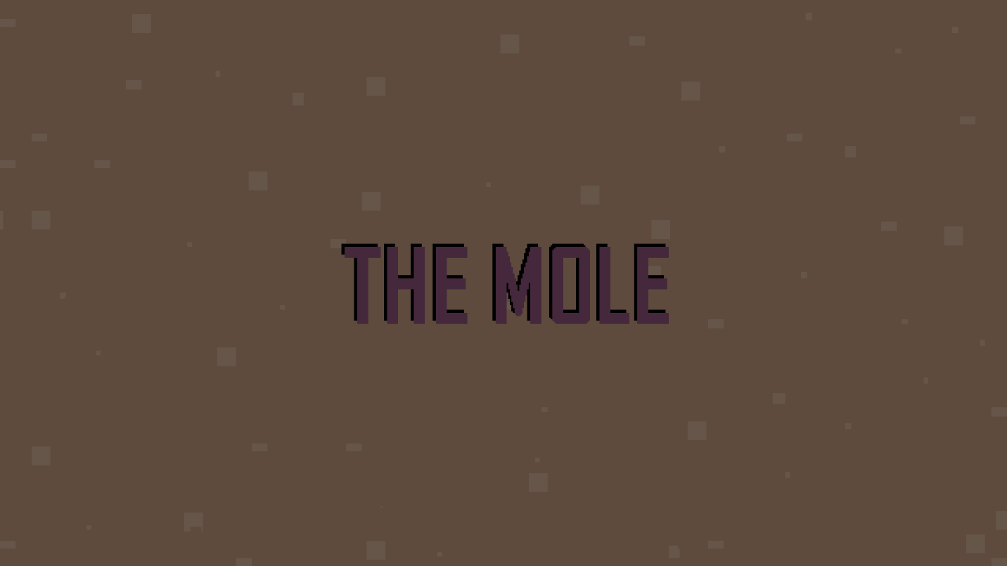

The MOLE

Ava McCormack

Version: 1.0

Overview

The MOLE is a pixel-art game similar to that of a roguelike. This means each playthrough gives the player an opportunity to create a unique build each time. Additionally, once a run ends whether through winning or losing all stats and upgrades are reset. In this game, the player must fight their way through waves of enemies and defeat the final boss.

Game Description

In this game, the player is a mole defending against waves of enemies by slashing through them. As a mole, the fighting territory is within the earth. Enemies are spawned off screen, and automatically hone towards the player. Periodically, stats boosts will be offered to the player where they may pick one from a random selection. In order to win, a player must defeat the final boss. Wave “levels” are decided by number of kills, and staying alive is the objective. The player will use a keyboard and mouse to move their character around. The standard WASD keys will control character direction, and the mouse will be used for attacking.

Assets Used

All Images I drew in Aseprite

* Ant-*x*-*y*.png
* Boss-0.png
* Difficulty.png
* Game-lost.png
* Game-won.png
* Map-*xy*.png
* Menu.png
* mole-*x*-*y*.png
* Ant-*x*-*y*.png
* Quit.png
* Settings-in-game.png
* Title-anim-*x*.png

Sound files

Downloaded from <https://www.freesound.org/>

* + Boss-proj-hit.wav
  + Hurt.wav
  + Slash_hit.wav
  + Slash_miss.wav

Music I made in GarageBand

* + Boss-music.wav
  + Music.wav

User Manual

Menu Screen

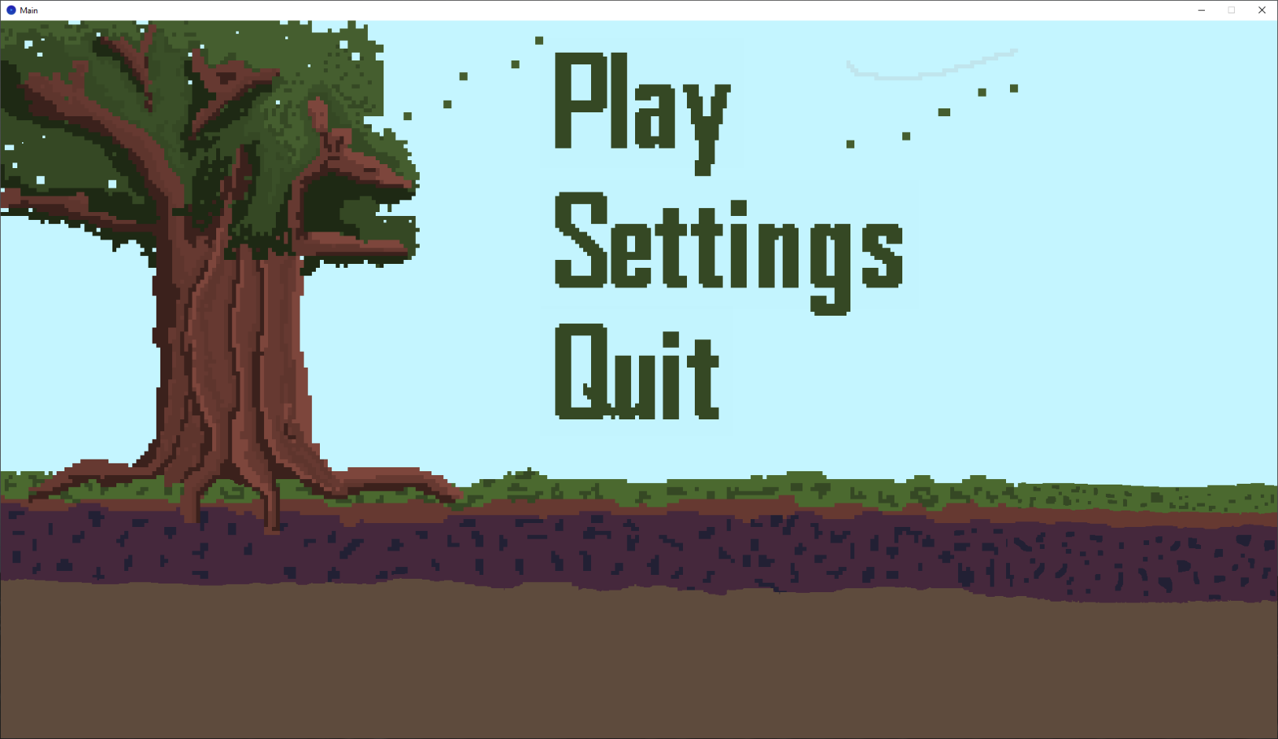Navigate with [Mouse Clicks]

Menu Screen [Mouse Click] Quit

Chance to confirm whether you would like to quit game or not

May either [Mouse Click] No or [Key Press] ESC to go back to Menu Screen

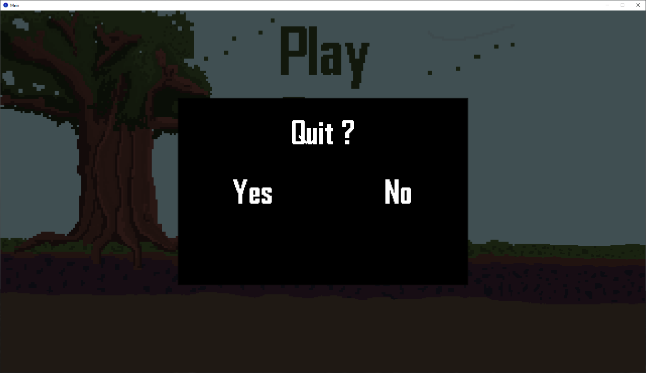[Mouse Click] Yes will quit game window

Menu Screen [Mouse Click] Settings

Music and SFX Volume Sliders to adjust volume

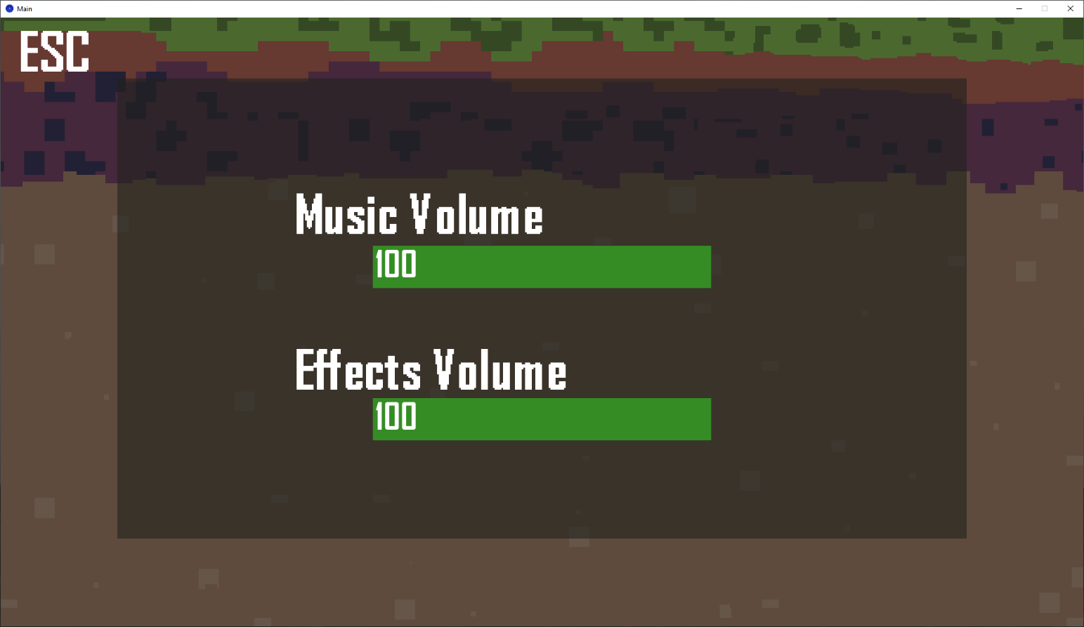May either [Mouse Click] ESC (in the left corner) or [Key Press] ESC to go back to Menu Screen

Menu Screen [Mouse Click] Play

Difficulty Selection Screen – choose difficulty of game with [Mouse Click]

May either [Mouse Click] ESC (in the left corner) or [Key Press] ESC to go back to Menu Screen

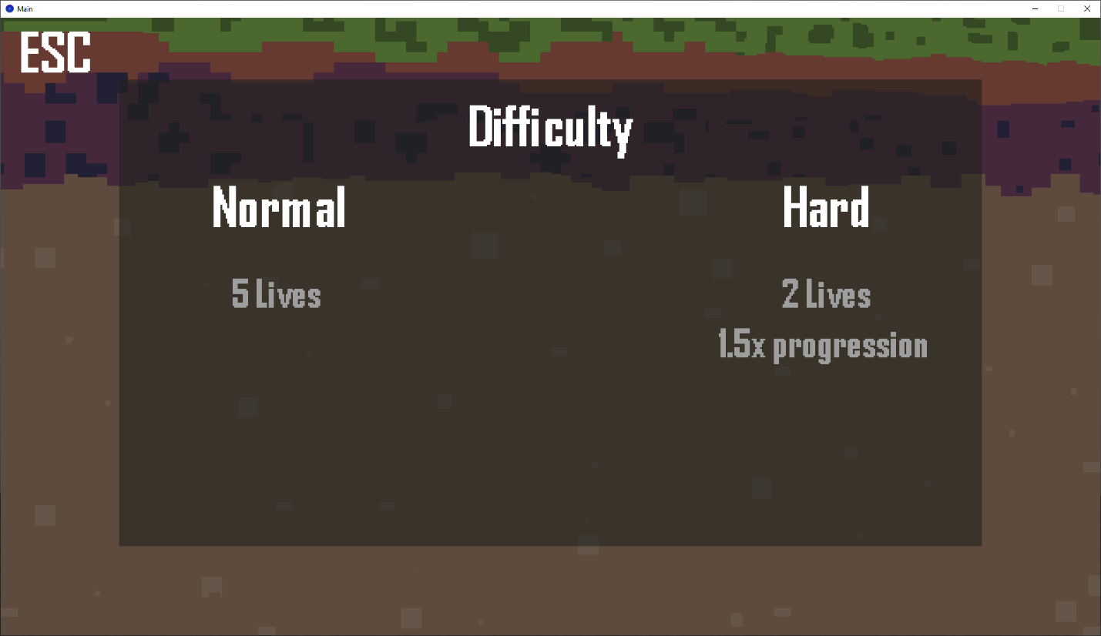

Difficulty Screen [Mouse Click] Normal || Hard

Begins Game Play

Note: Overlay : Health, Kills, and Level

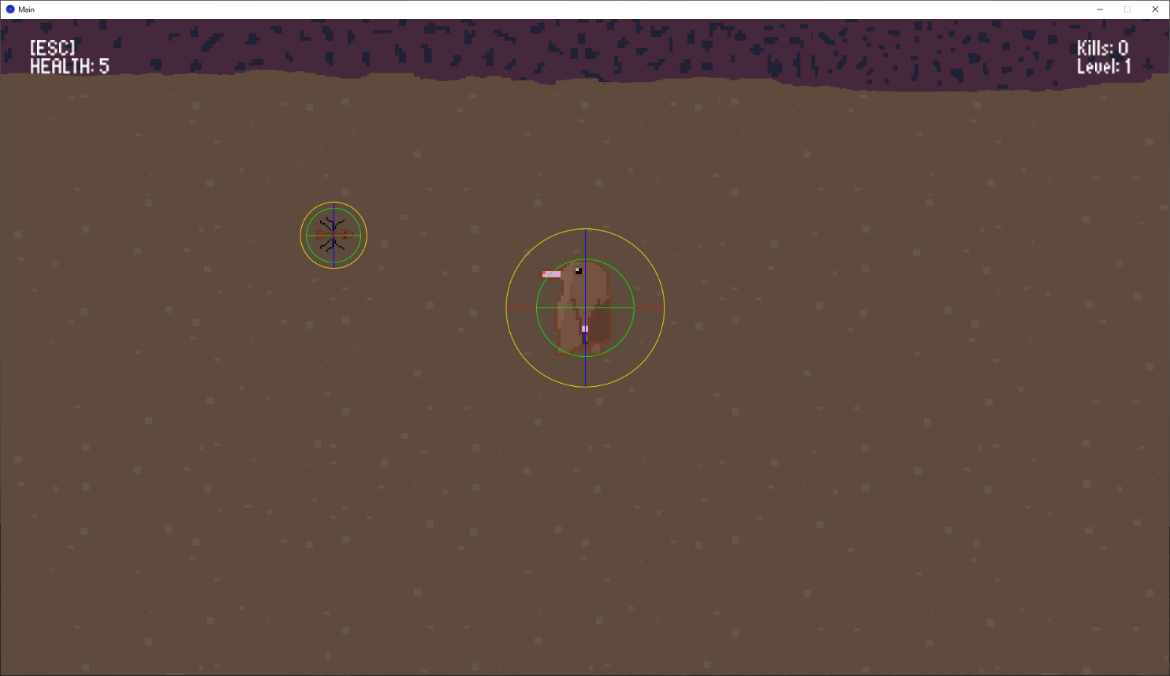

[Key Press] ESC to enter In-Game Settings

Music and SFX Volume Sliders to adjust volume with Mouse Press

May either [Mouse Click] Resume or [Key Press] ESC to go back to Game

[Mouse Click] Quit to Menu to quit game and go to Menu

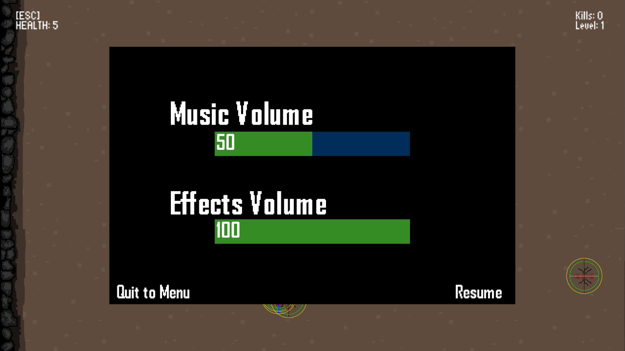

Game Movements

WASD Key input will control direction of character

W – Up



S – Down



A – Left



D – Right



Diagonal Movement

[Mouse Click] will prompt Player to attack



On Increase of Level, UPGRADE Screen will show

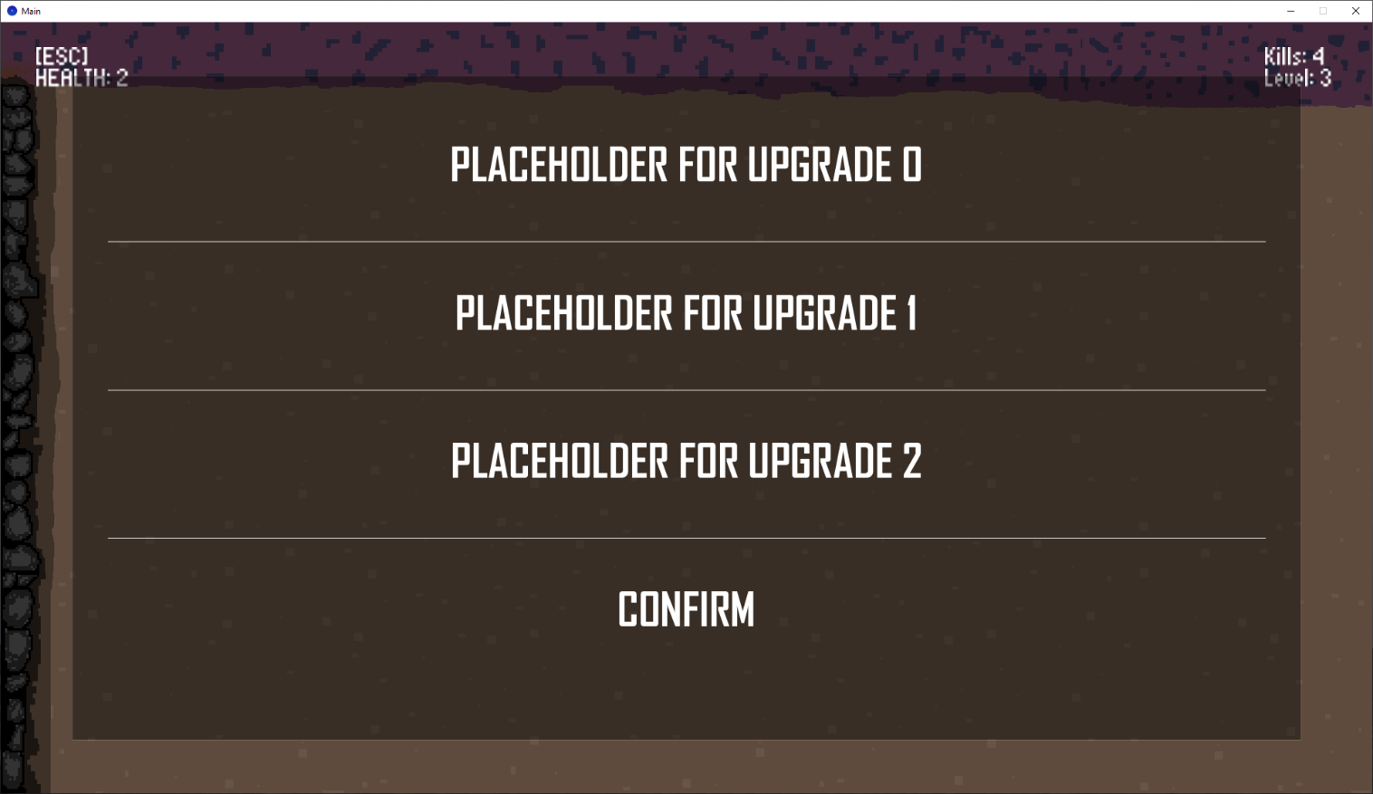

[Mouse Click] on Upgrade to Select it

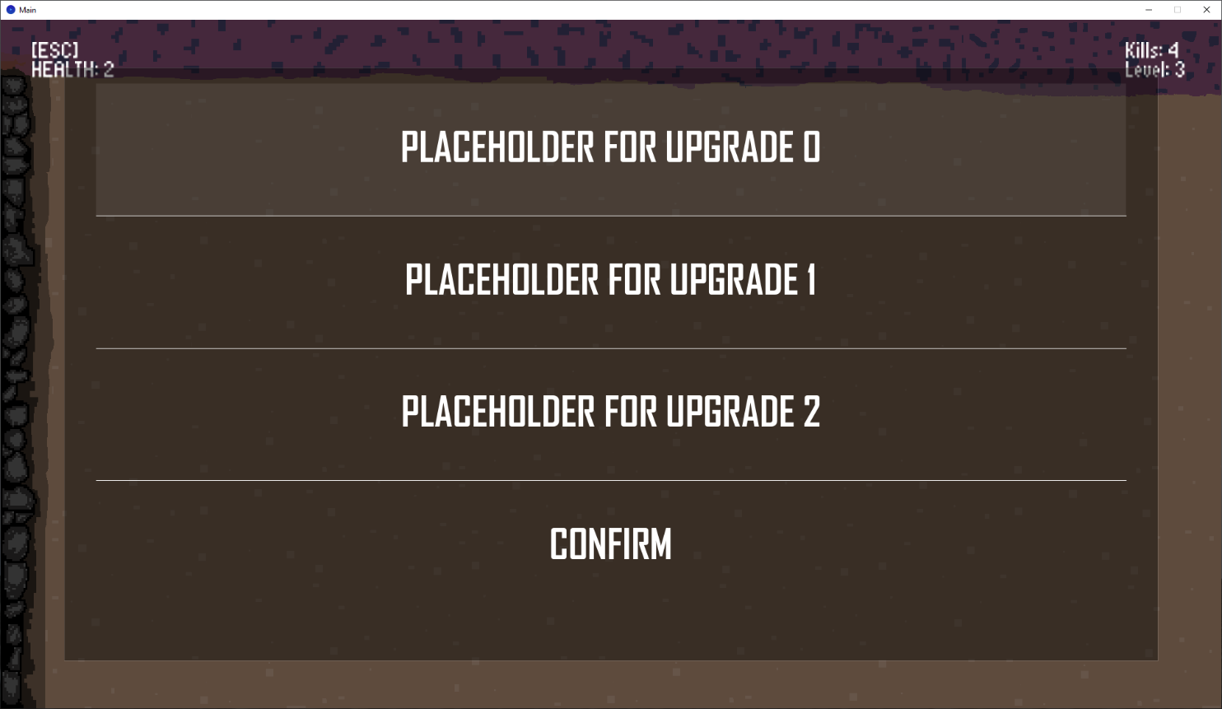

[Mouse Click] Confirm to confirm selection and resume game

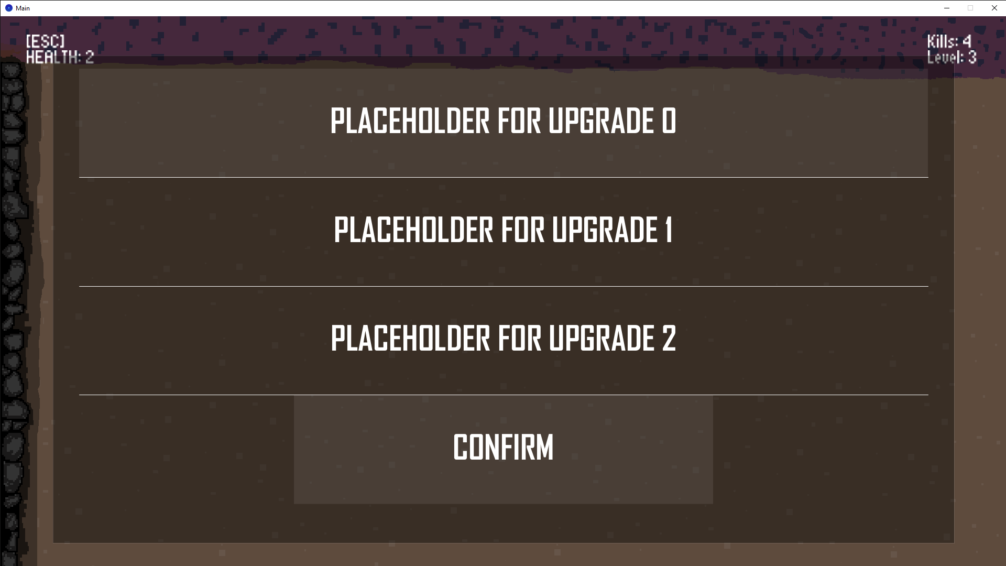

Roles and Responsibilities of Each Team Member

Everything – Ava